Autumn holiday home learning activities October 2023

These are just for fun, there is no pressure to complete them. If you do choose to complete them, we would love to see pictures of anything you do in Nursery School after the half term holiday.

Go on an Autumn sensory walk

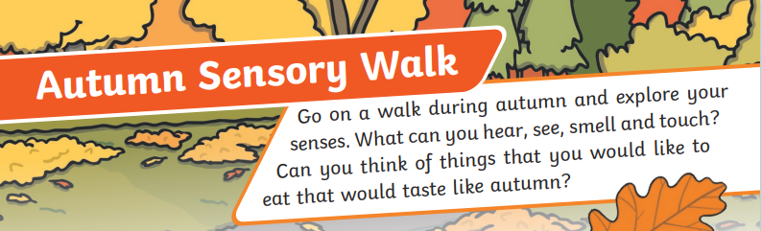

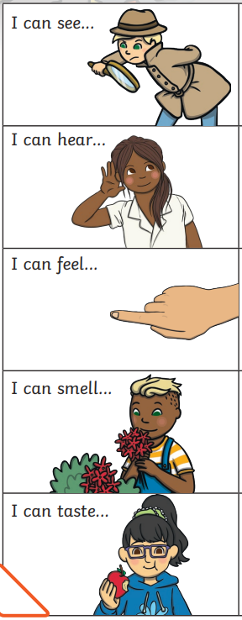 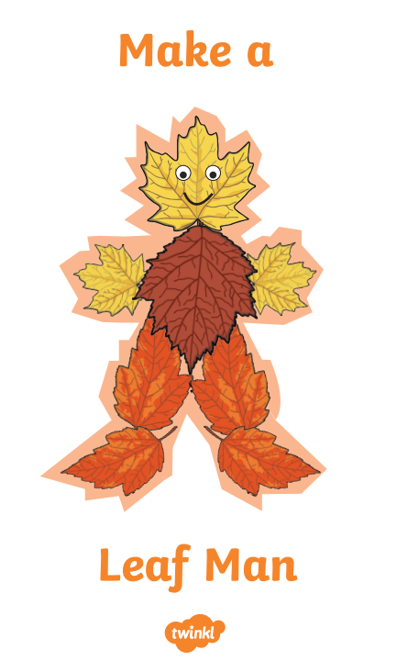

Collect some leaves while you are walking to make a picture. You could make a leaf man like the one below or something different.

What can you see on your walk?

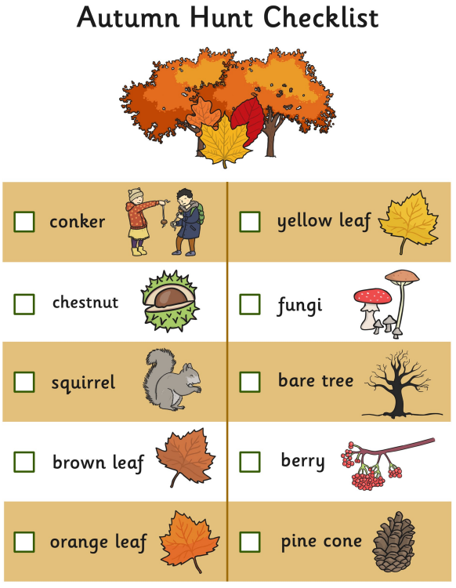

Talk about the colour.

Talk about the shape – are they round?

- do they have pointy bits?

Talk about the size – are they big or small? – long or short?

Talk about how many there are – is there one? Two? Lots?